1. **Login Page: Username + Password**
2. **4 Tabs :** Audio Manager, Playlist Manager, Image Manager & Play History
3. **Audio Manager**

Audio manager should have the ability to Add, Edit & Delete Songs.

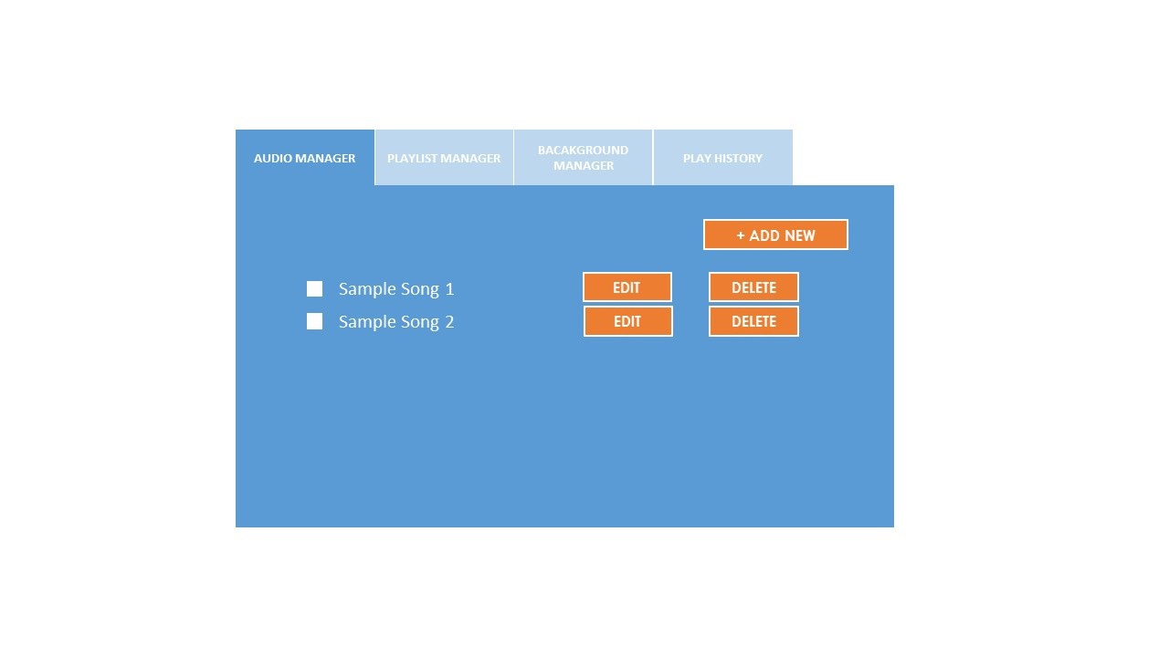

Clicking on Add/Edit takes you to page to upload Mp3 songs or edit properties of existing one. Mp3s will be uploaded to folder as defined in properties file. Cover Art will upload to directory as defined by properties file. Also cover art should match resolution defined in properties file.

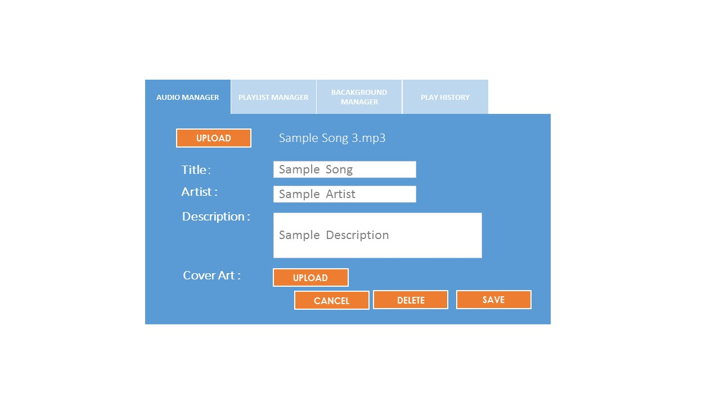

1. **Playlist Manager**

Playlist manager should have the ability to add, edit or delete a playlist. Also have the option to set one playlist as current playlist

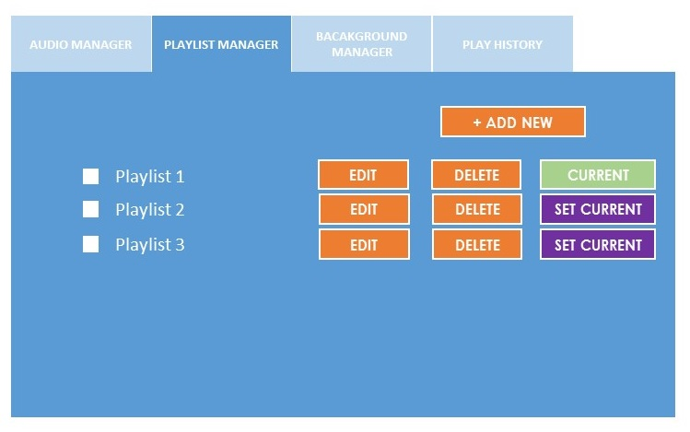

Should have the ability to add songs from the song list to current playlist list. A song can be added multiple times. On the right, should be able to order the songs in the playlist

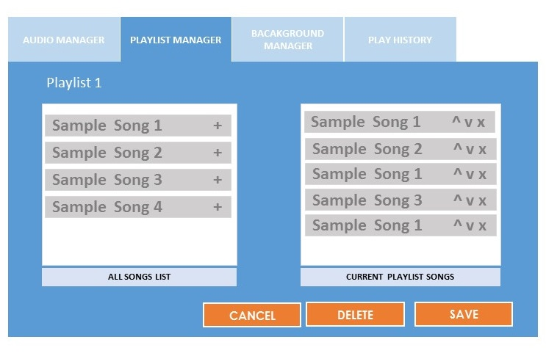

1. **Background Manager**

Should have the option to add, edit and delete background .

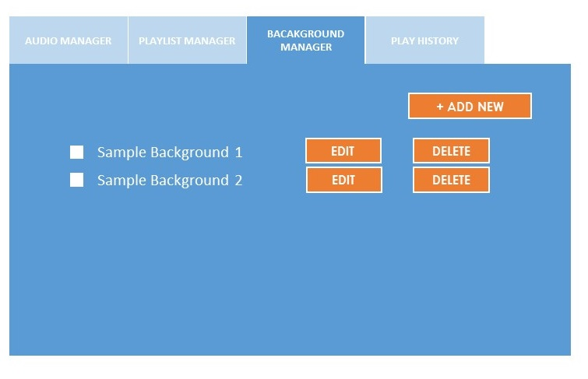

Should verify size when uploading as defined in a config file.

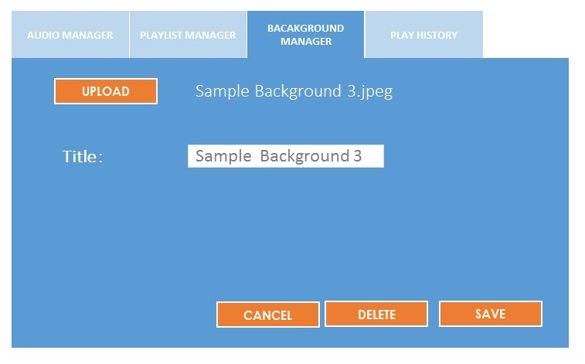

1. **Play History**

Shows history of all songs played . Shows the following fields.

***Playlist Name, Songs Name, Background Image, Date, Time***

Option to download as csv file and also purge /delete history.

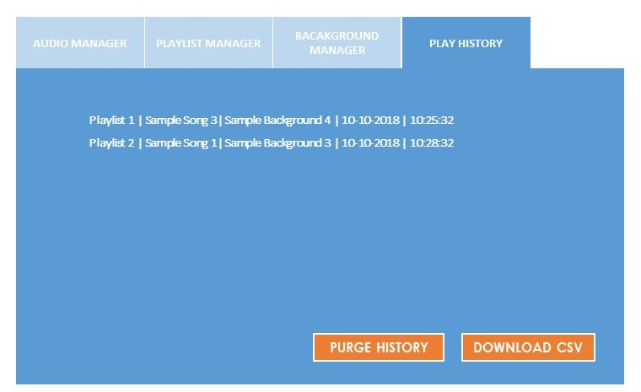

1. **playnext.php**

This is a command line file that returns the following values as a csv or tsv (Should be easy to configure in php file)

***Playlist name, Song location, Song Name, Song Artist, Song Description, background location .***

Logic is as follows

1. Check current playlist selected
2. If current playlist has been edited, return the first song from the playlist. Else if no change return the next song of the current playlist. If playlist list if over starts from first song again.
3. If current playlist has been changed to a new one, start with first song of new one.
4. Make an entry in playlist history
5. Return background image with every songs change. Should cycle through. If any new background is added or removed, start from the beginning.
6. **Other Requirements.**

**Should use mysql database. Code should be simple and clean. Config file should be available for parameters such as database, folders etc, image sizes etc.**